In September, the Centre for Ageing Better – supported by Public Health England – launched a competition inviting designers to rethink the symbols and icons commonly used in public to represent older age groups.
The project was incredibly well received and shared – the conversation continued beyond social media with the competition capturing attention on national TV.
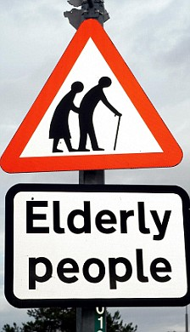
With more than 120 submissions, the entrants drew on a range of ideas, from abstract concepts such as tree rings, to re-imaginations of the walking stick.
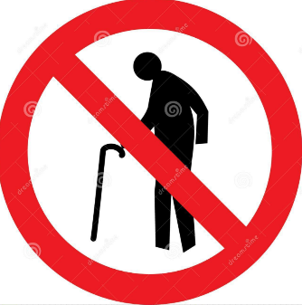
The winning entry, as chosen by the judging panel, was a submission from SwaG Design which gave the original symbol of the couple crossing the road a unique spin.
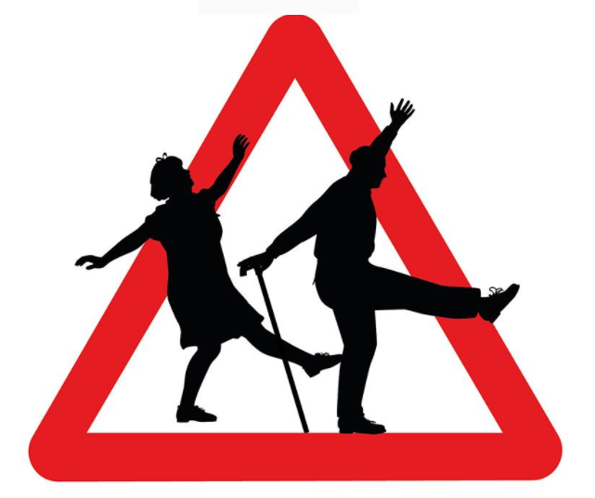

SwaG Design were inspired by their work with the organisation Intergenerational Music Making saying, ‘we chose to evolve the current UK road warning sign for older people hunched over by providing a positive reason for the posture. Dancing is one of the things that people of all ages love as it promote physical, mental and emotional health as well as a chance to be sociable, expressive and uplifting.’
With this as the inspiration they reimagined the existing icon as two older people dancing across the street, the walking stick becoming a dancing cane.
The judges were pleased with the design being able to capture the diversity of older people, portraying an active and social pair, while breaking out of the triangular road sign shape.

The judges would also like to recognise the runners-up of the competition:
Red Stone

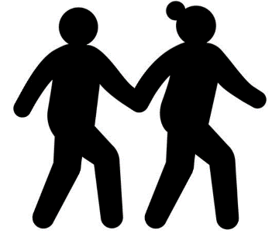

Studio Smile Ltd
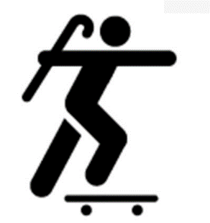

Jonny Acheson

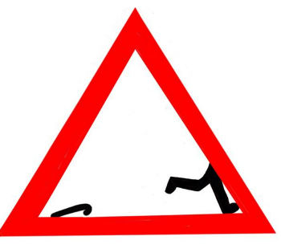

Fitzpatrick Design
