Update 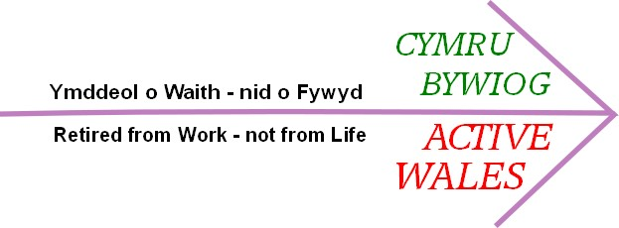
Newsletter of Wales’ Oldest Organisation for Retired People Issue No. 1 November 2014

Welcome to the first edition of our updated newsletter. We will be producing it regularly to keep members informed. We hope that it will also be a way of letting members publish their news and stories.

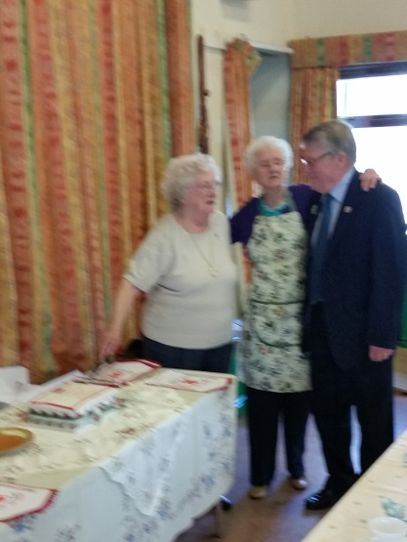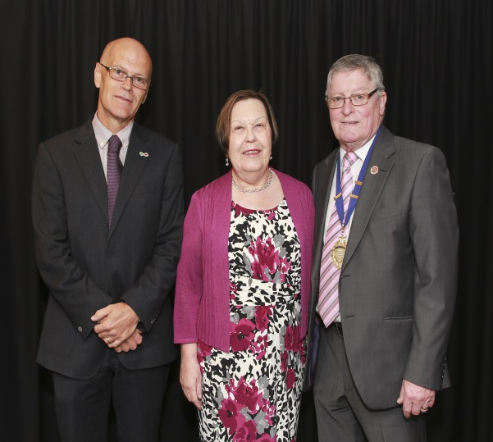

Three Chairs for Age Positive Week. Nesta Rowlands (Upper Rhymney Valley Area) and Amy Holifield( Darran Valley 55 Club) with National Chair John Davies. | Annual Conference 2014.Ian Thomas of Age Cymru with our President Baroness Gale and Chair John Davies.

This newsletter is being used to explain the new “Brand” for the NOAPAW. For some time many people, inside and outside the Association, have felt that the name and the Dragon emblem are too old-fashioned for modern times. This Association has an important role to play in doing something about the increasing problems of isolation and loneliness among retired people. Our members are the ones most likely to be in contact with such people in their own communities. To carry on with this important work, we need to be a thriving organisation. To thrive, we must modernise with a new brand name Active Wales and a new logo.

The new logo is to be seen at the top of this newsletter. It will be used on all our materials from now on. The NOAPAW name will be kept for business purposes and the Dragon emblem will be used on ceremonial occasions.

Your Executive Council is now in the process of ordering new promotional materials with the new name and logo. These will be used as “freebies” at events where we can advertise the Association. This is intended to help recruitment of new members and new branches. So if you learn of any events in your area where we could set up a stall, the Executive would be very grateful if you let us know. We will do our very best to attend and get the Association better known.
Please use the contact details below to send us your venue suggestions, news, stories and pictures.

